SECTION B
AUTHENTICATION ENDPOINT
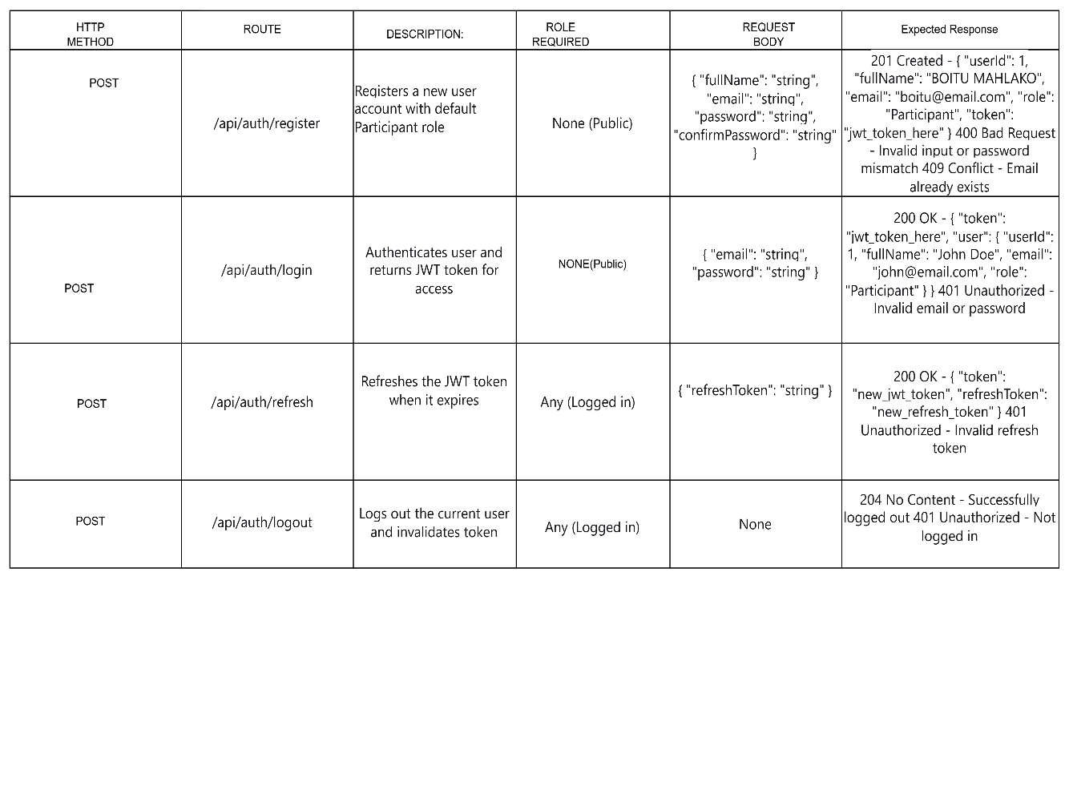

USER PROFILE ENDPOINT

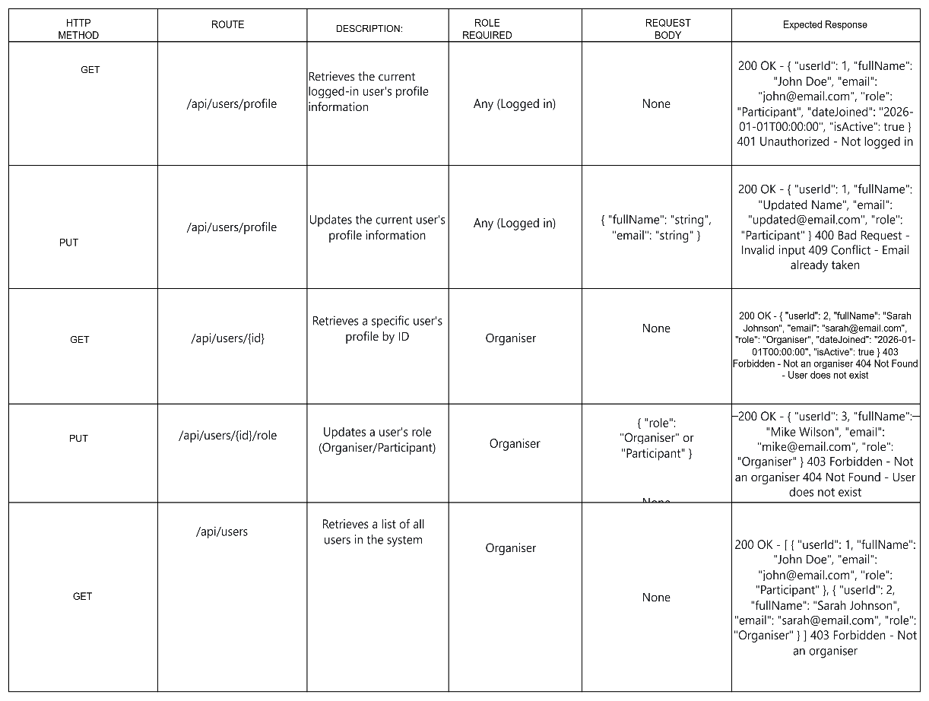

EVENTS ENDPOINT
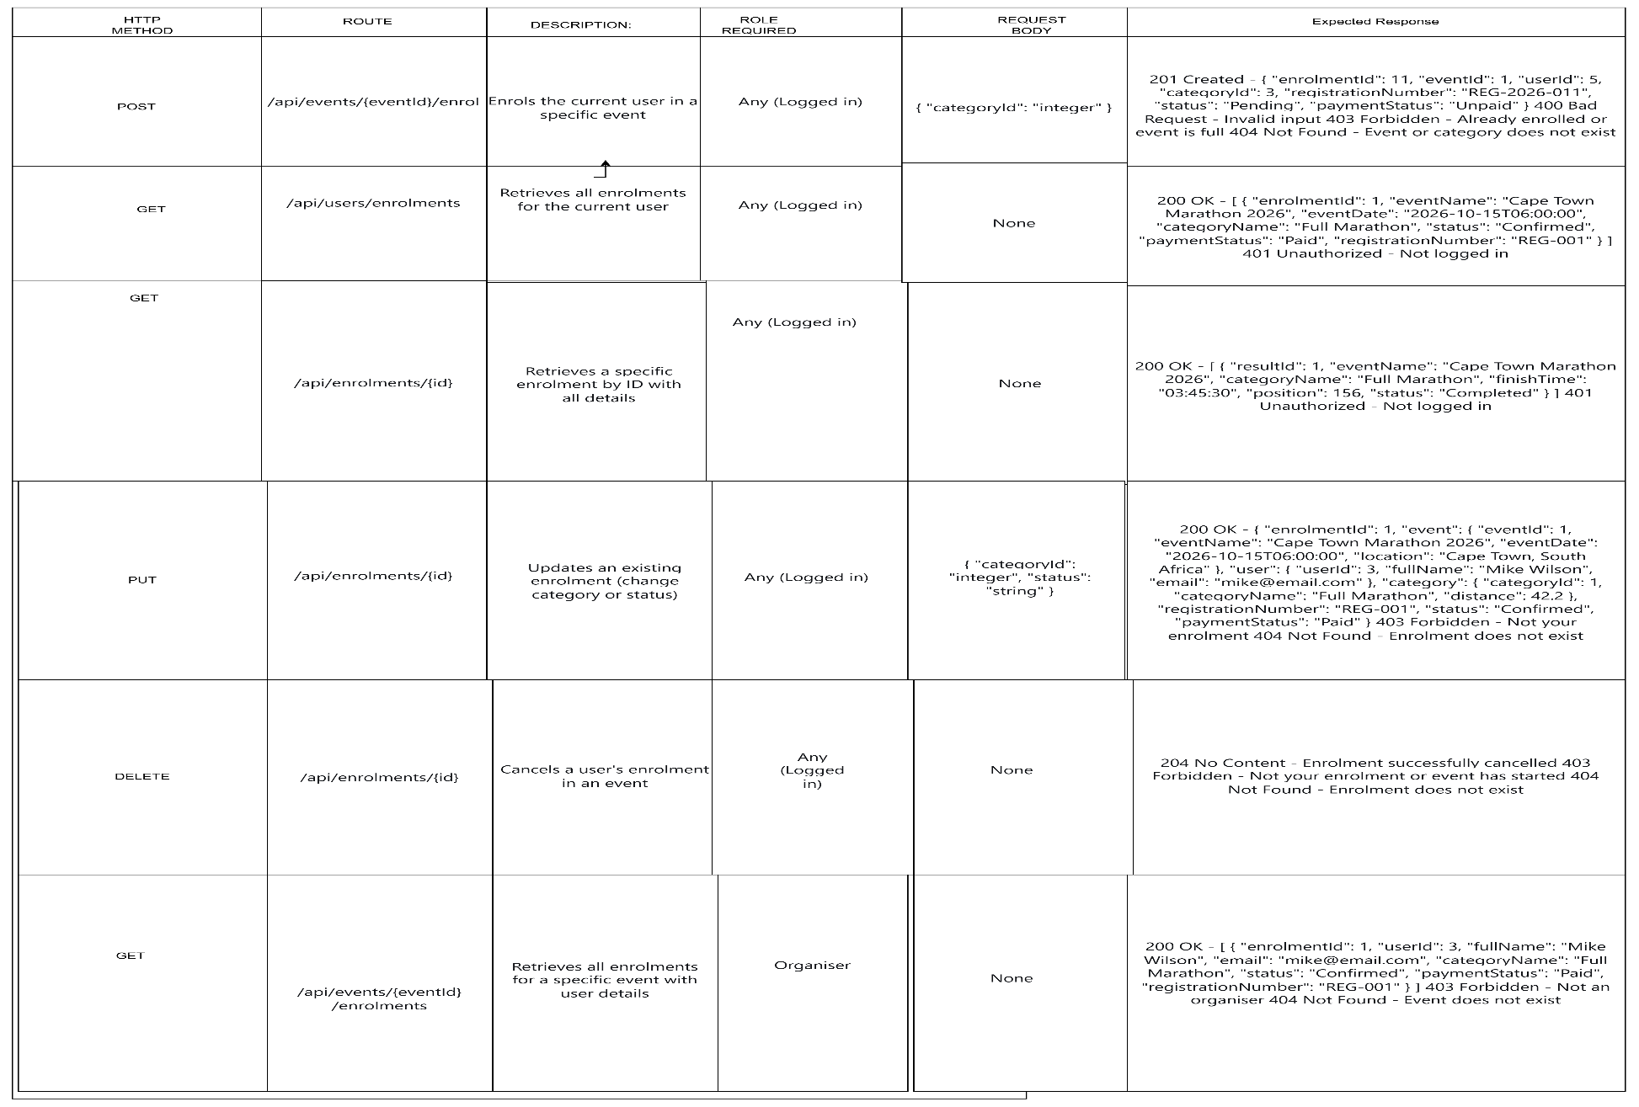

CATEGORIES ENDPOINT

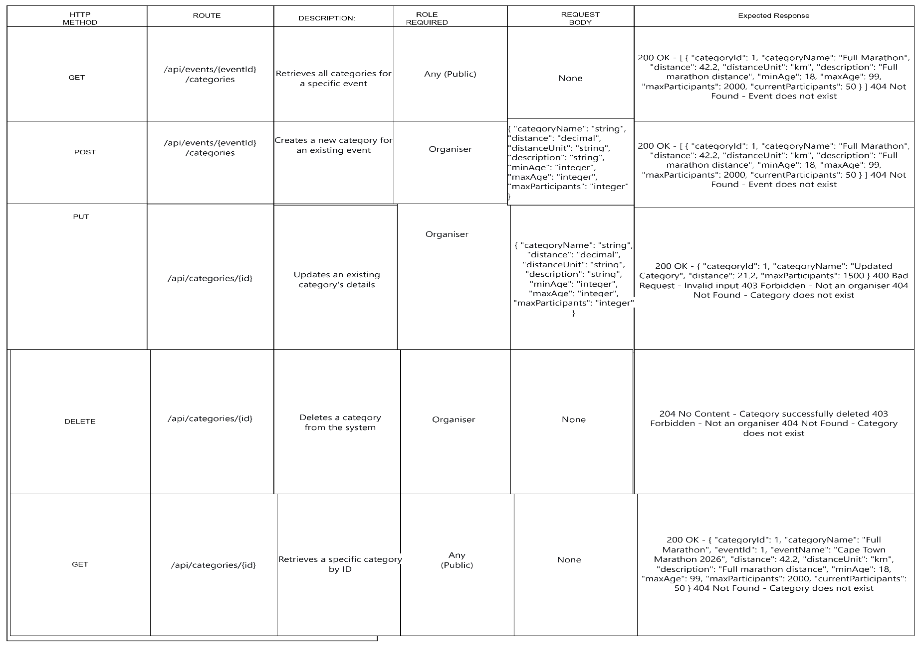

ENROLLMENT ENDPOINT

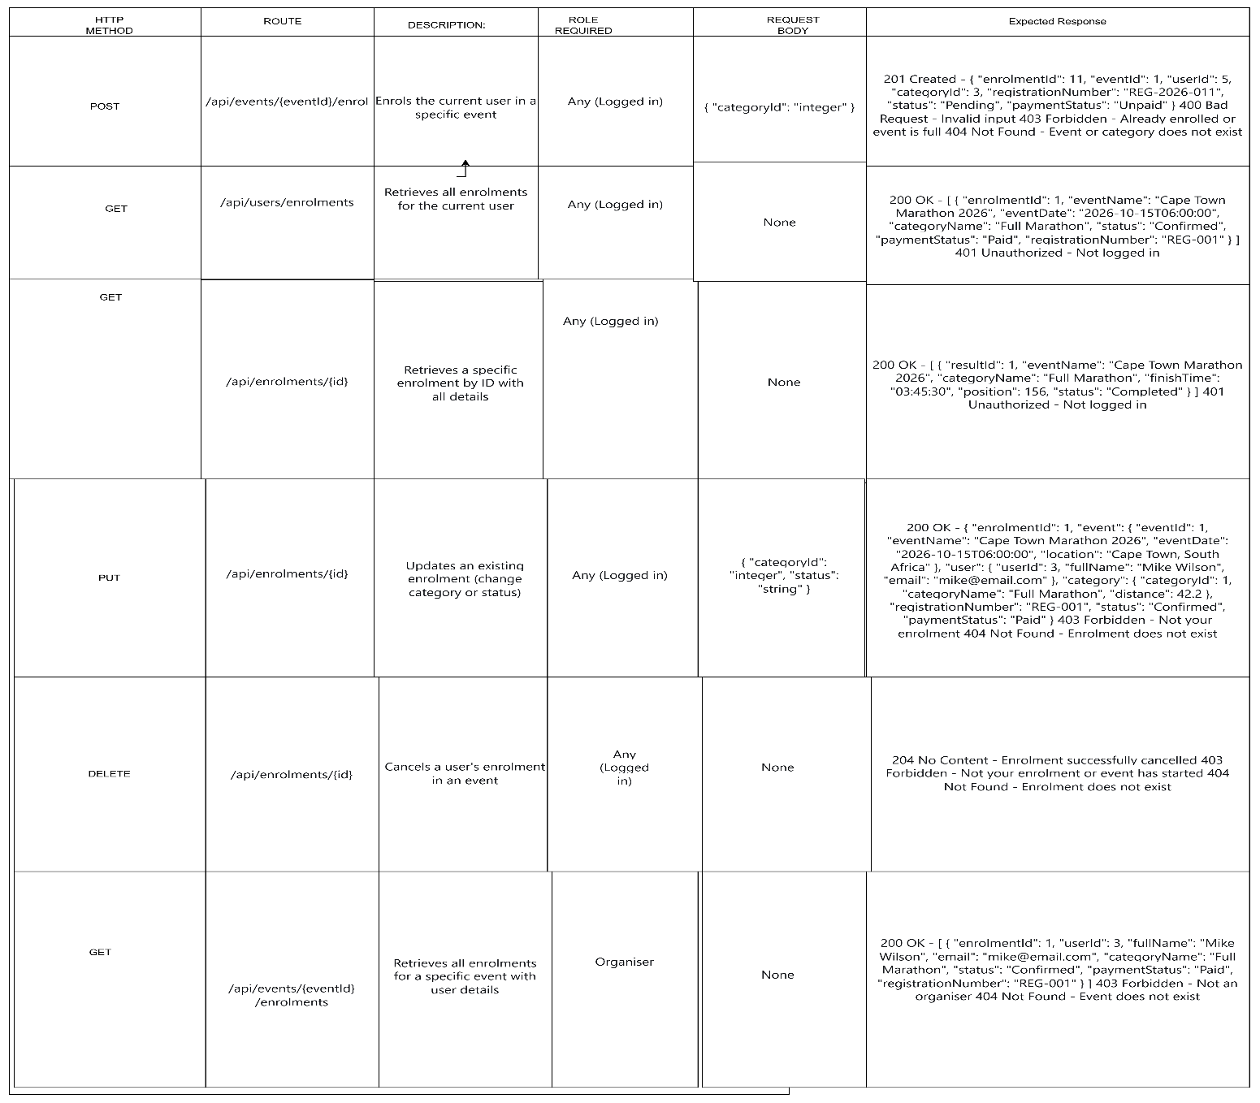

RESULT ENDPOINT
